<https://www.youtube.com/watch?v=sQ870aTKqiM&list=PLblh5JKOoLUICTaGLRoHQDuF_7q2GfuJF&index=44>

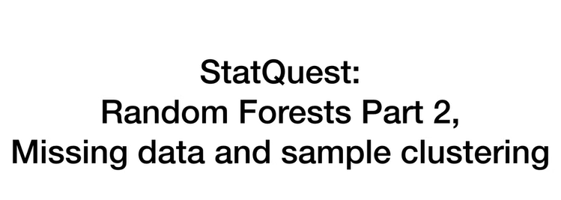

Today we're doing random forests part two and we're gonna focus on missing data and sample clustering.

To be honest, the sample clustering aspect of random forests is my favorite part, so I'm really excited we're gonna cover it.

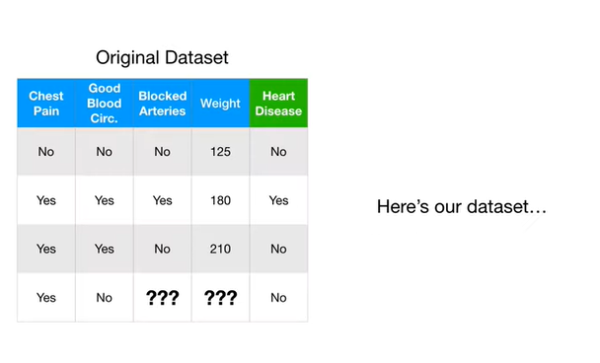

Here's our data set.

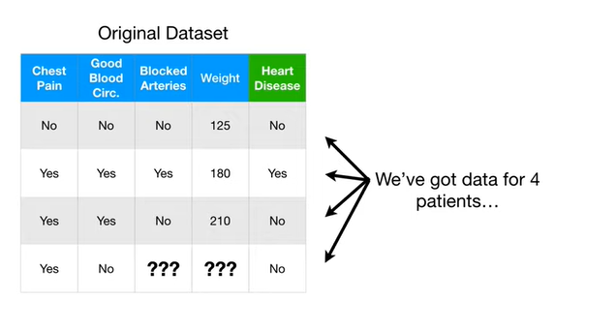

We've got data for four separate patients.

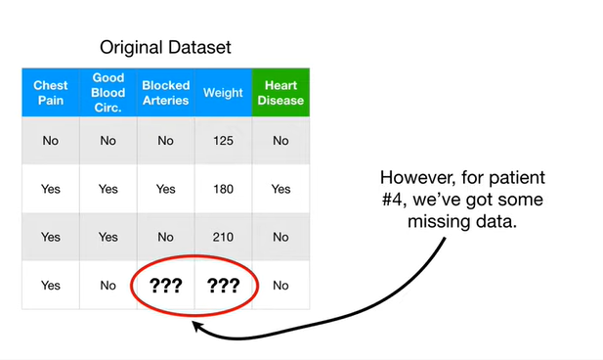

However for patient number four we've got some missing data.

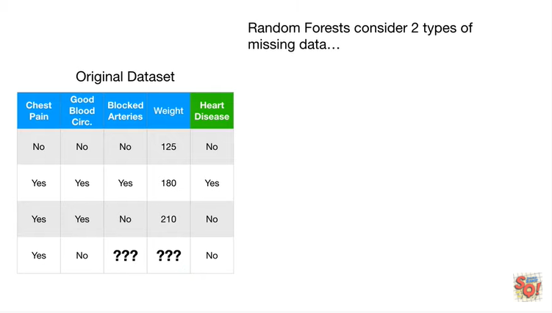

Random forests consider two types of missing data :

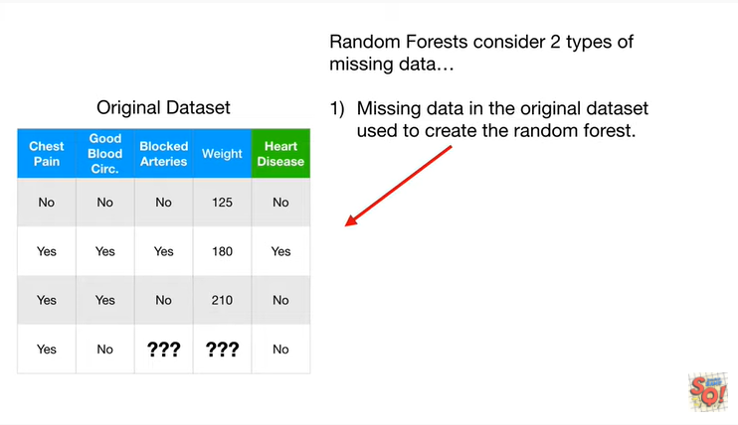

1. missing data in the original data set used to create the random forest

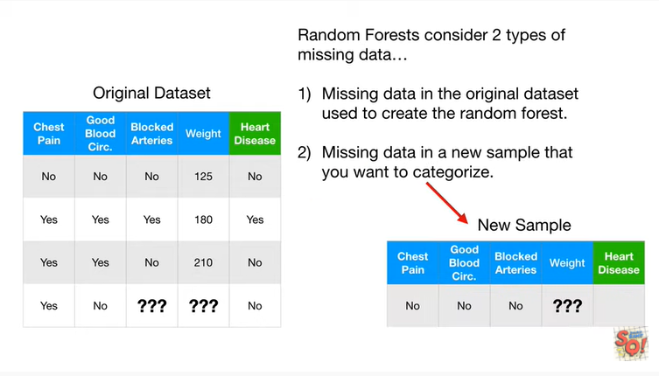

and 2. missing data in a new sample that we want to categorize.

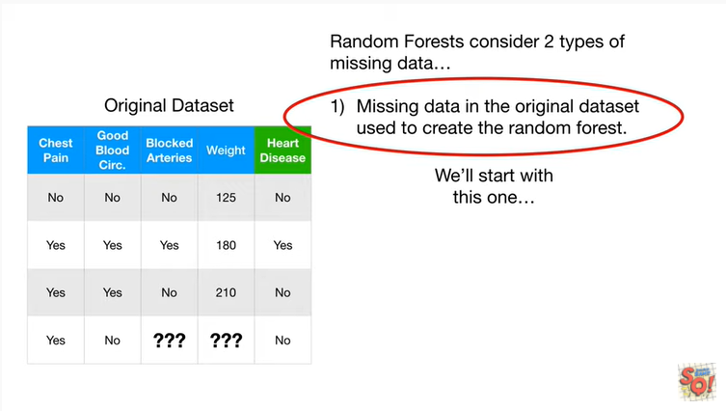

We'll start with this one.

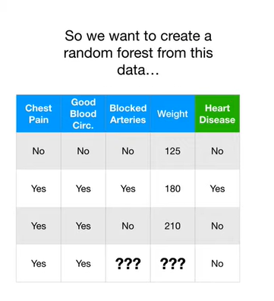

So we want to create a random forest from this data.

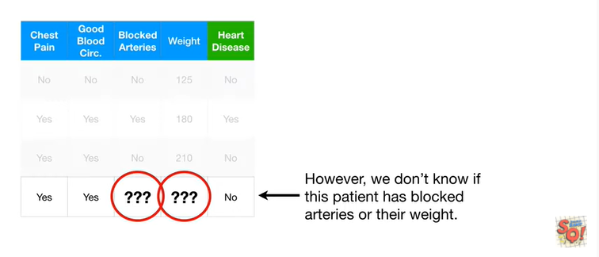

However, we don't know if this patient has blocked arteries or their weight.

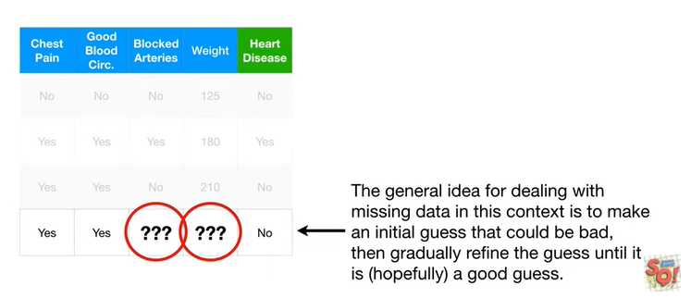

The general idea for dealing with missing data in this context is to make an initial guess that could be bad and then gradually refine the guess until it is hopefully a good guess.

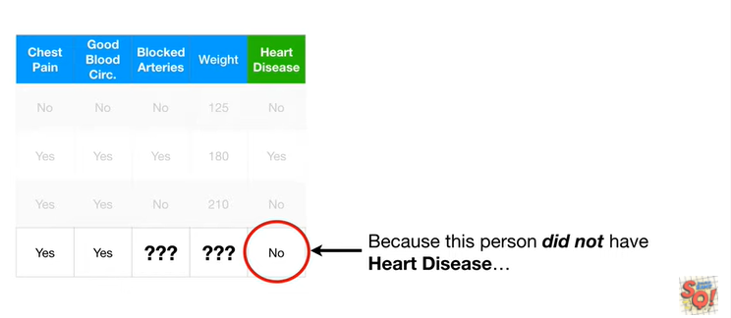

Because this person did not have heart disease

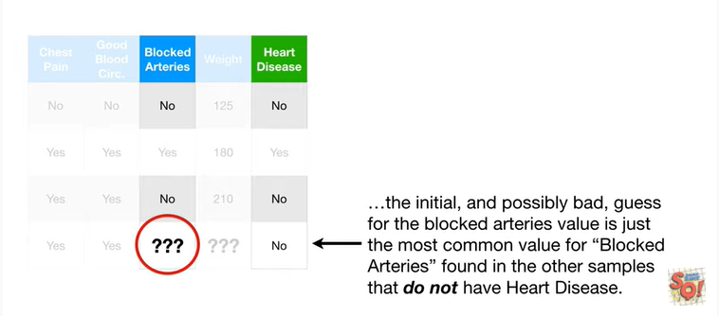

the initial and possibly bad guests for the blocked arteries value is just the most common value for blocked arteries found in the other samples that do not have heart disease.

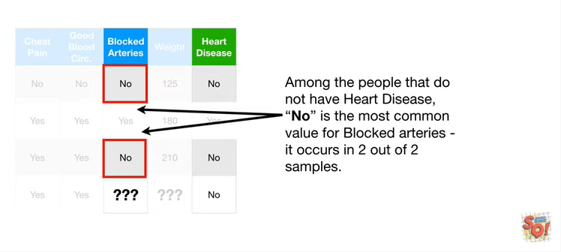

Among the people that do not have heart disease – no - is the most common value for blocked arteries it occurs in two out of two samples.

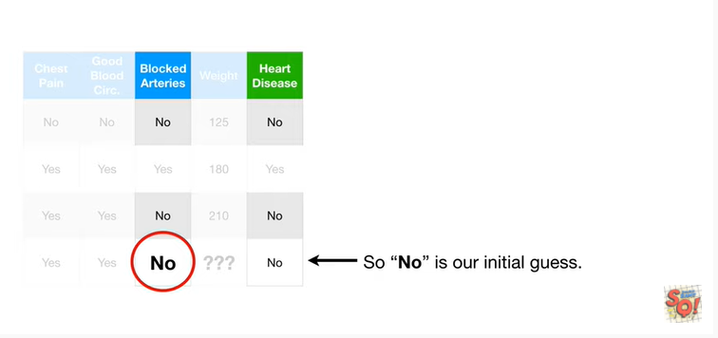

So no is our initial guess.

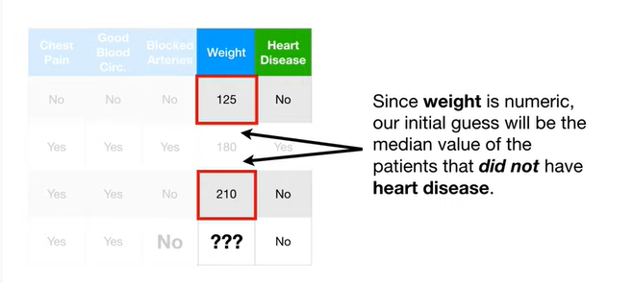

Since weight is numeric, our initial guess will be the median value of the patients that did not have heart disease.

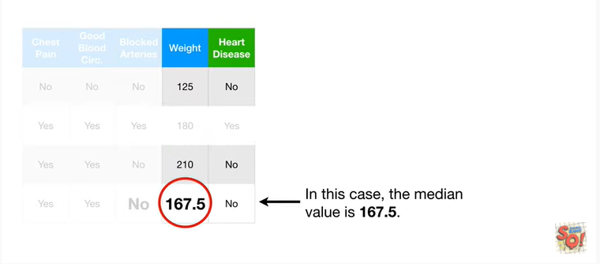

In this case, the median value is 167.5.

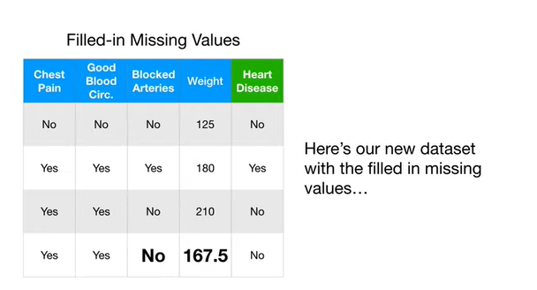

Here's our new data set with the filled in missing values.

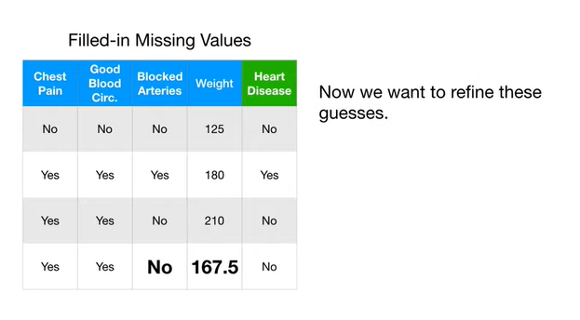

Now we want to refine these guesses.

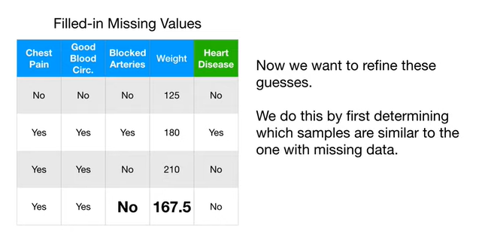

We do this by first determining which samples are similar to the one with missing data.

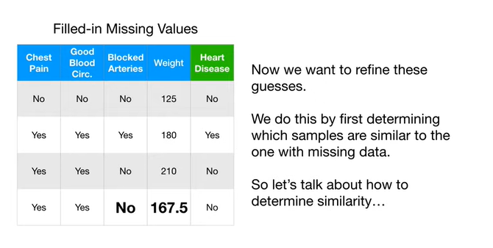

So let's talk about how to determine similarity.

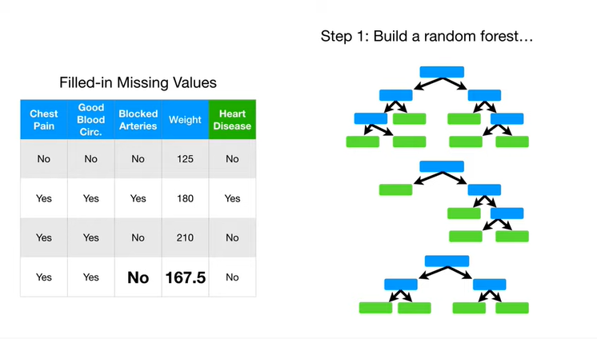

Step 1 : build a random forest.

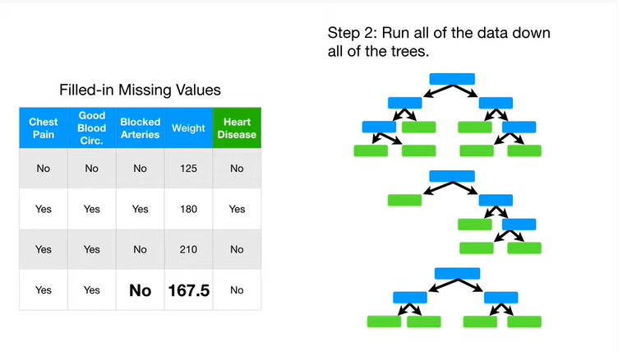

Step 2 : run all of the data down all of the trees.

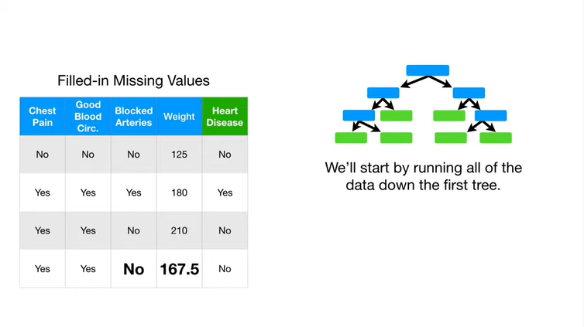

We'll start by running all of the data down the first tree

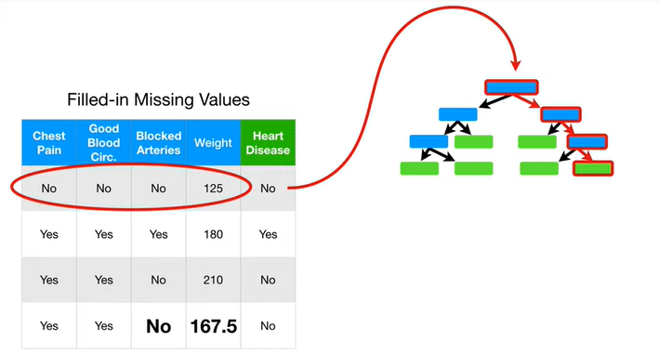

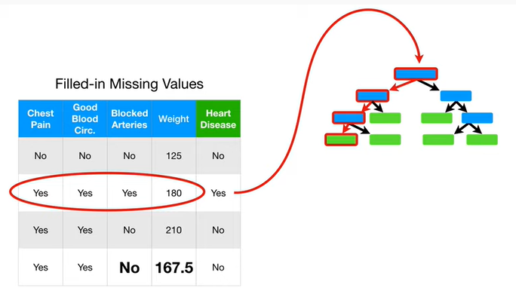

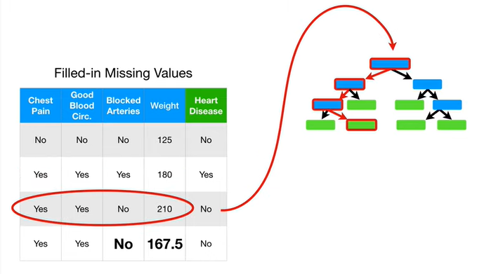

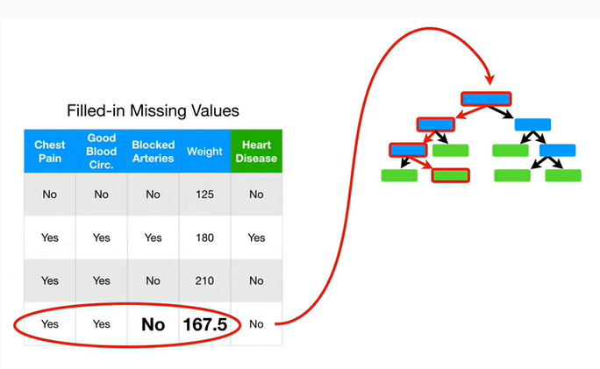

dooba dooba dooba dooba dooba do dooba dooba dooba dooba dooba dooba do Duke do this boo.

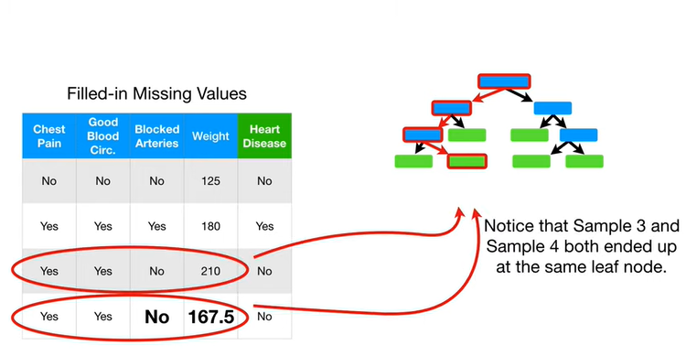

Notice that sample three and sample for both ended up at the same leaf node.

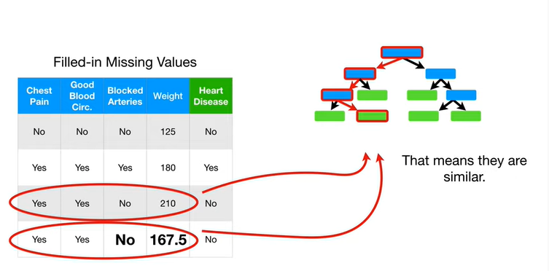

That means they're similar.

At least that's how similarity is defined in random forests.

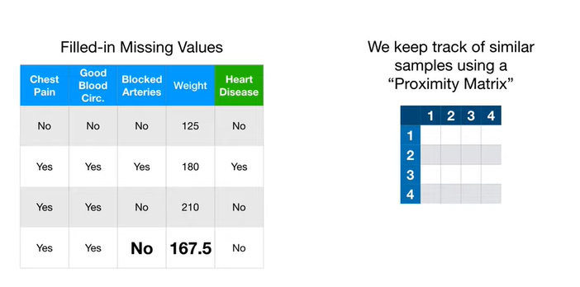

We keep track of similar samples using a proximity matrix.

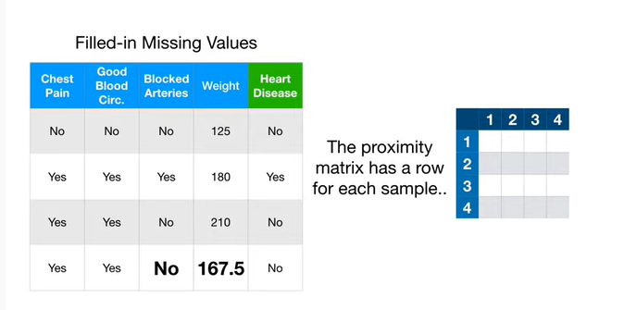

Te proximity matrix has a row for each sample

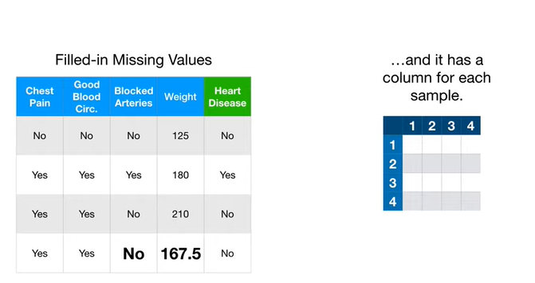

and it has a column for each sample.

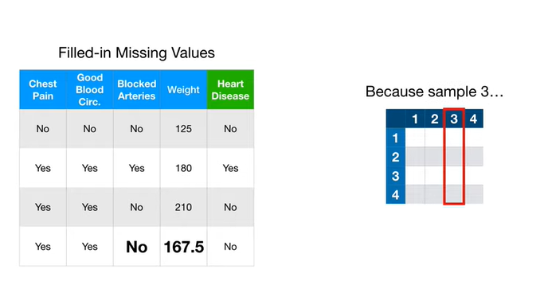

Because sample three

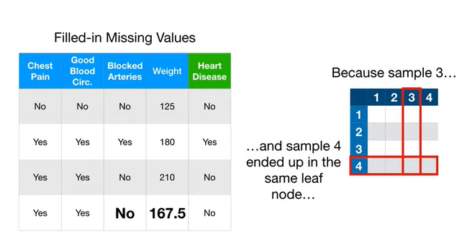

and sample four ended up in the same leaf node

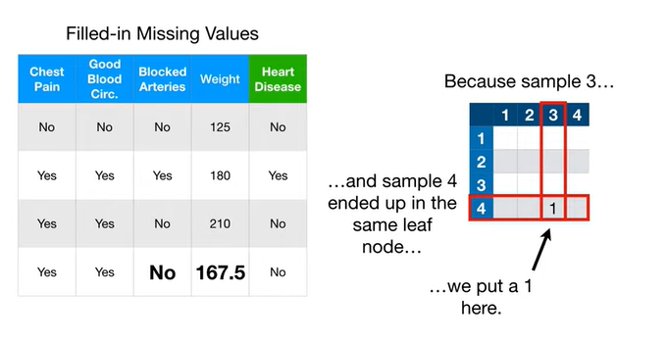

we put a one here.

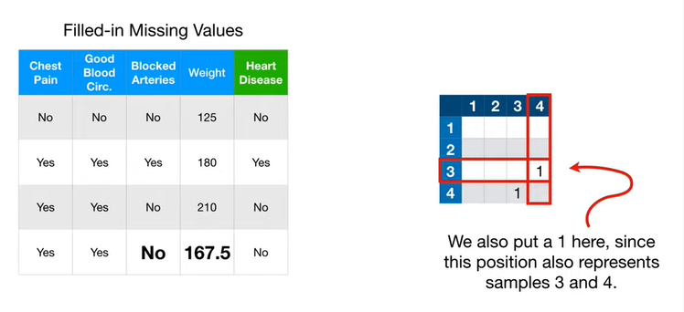

We also put a one here since this position also represents samples three and four.

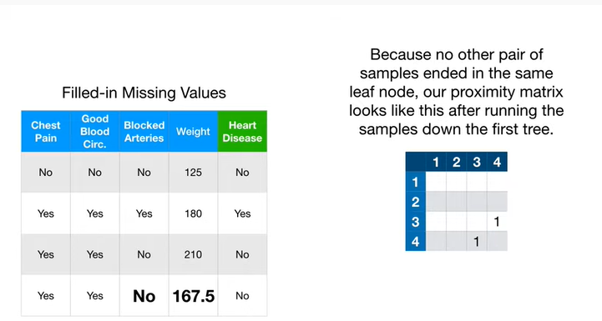

Because no other pair of samples ended in the same leaf node our proximity matrix looks like this after running the samples down the first tree.

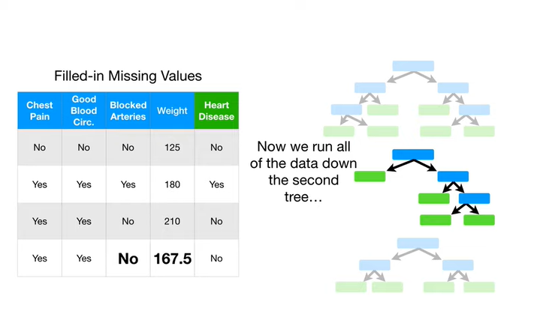

Now we run all of the data down the second tree

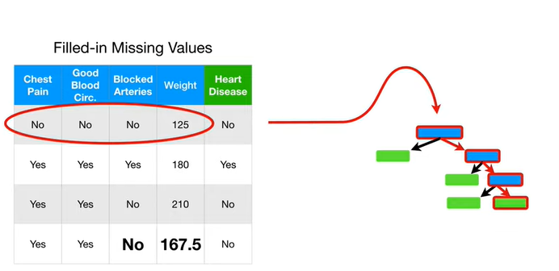

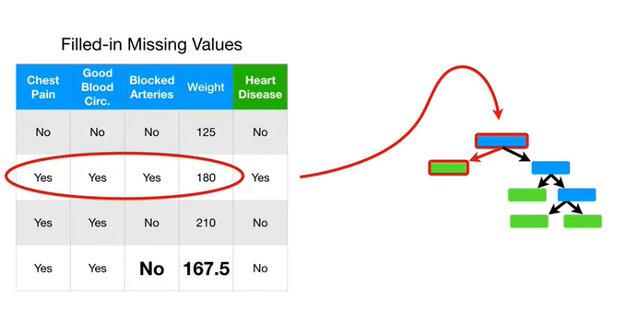

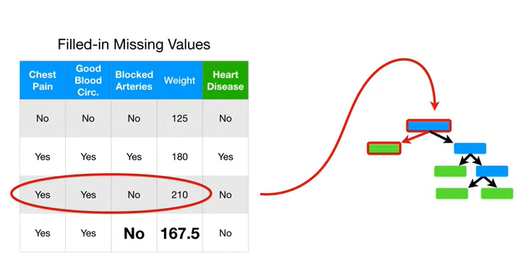

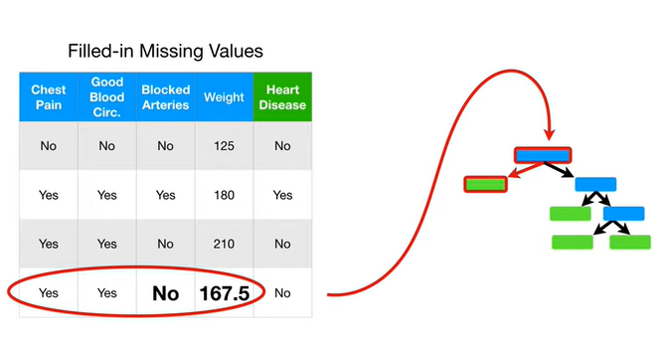

bet it boop bop bop bop better but but buttered up oh but up up up but I don't bump up but out up buh-buh-buh

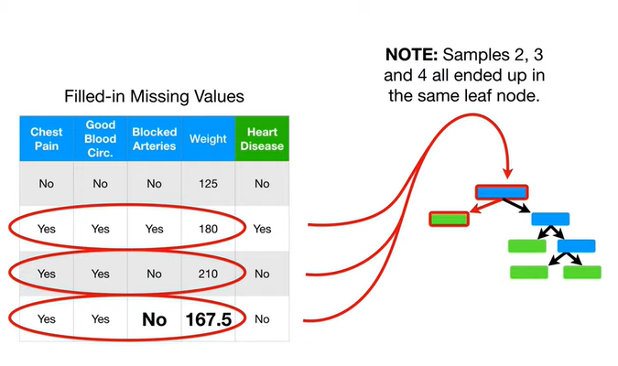

Note : samples two three and four all ended up in the same leaf node.

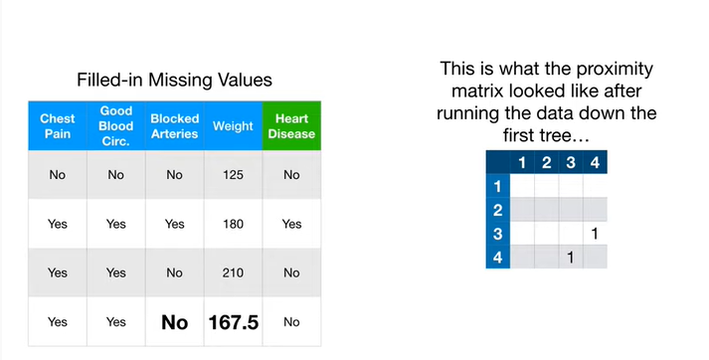

This is what the proximity matrix looked like after running the data down the first tree

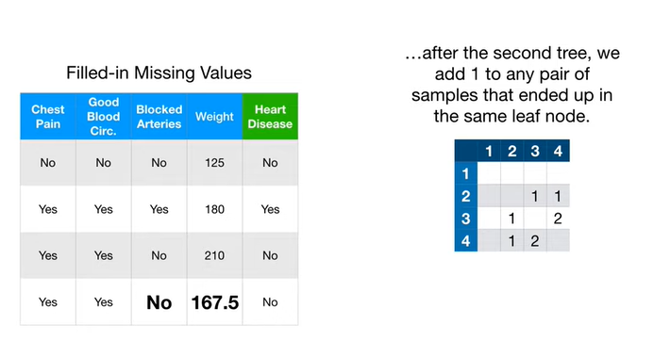

and after the second tree we add one to any pair of samples that ended up in the same leaf node.

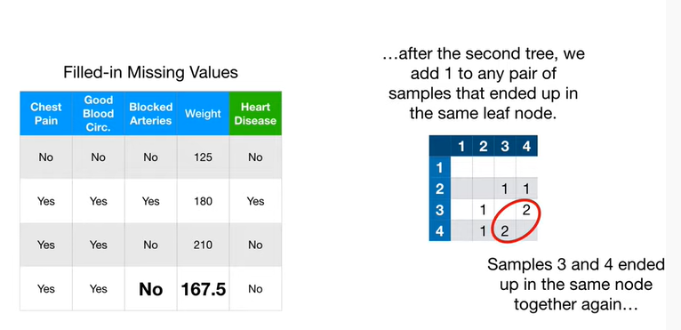

Samples three and four ended up in the same node together again

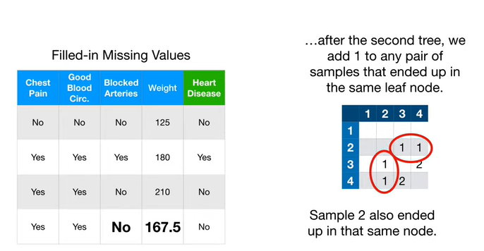

and sample two also ended up in that same node.

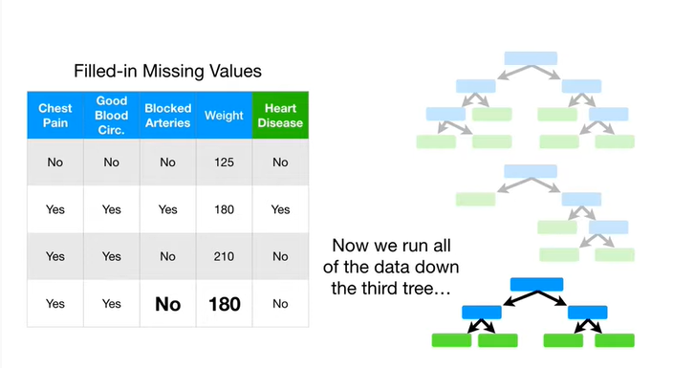

Now we run all of the data down the third tree

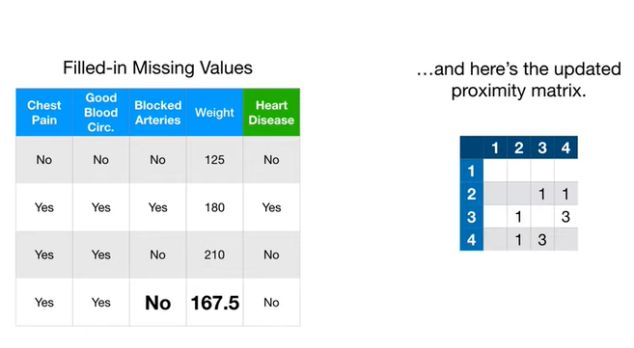

and here's the updated proximity matrix.

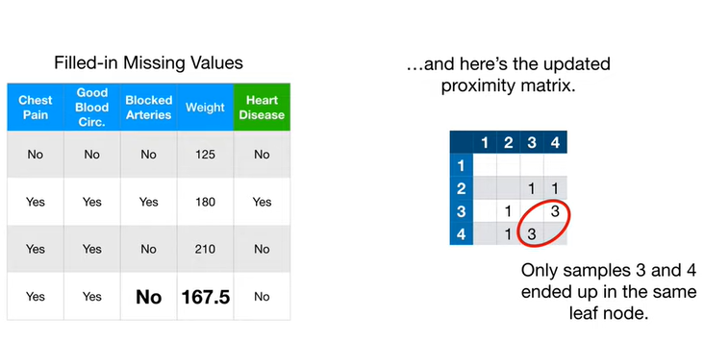

Only samples three and four ended up in the same leaf node.

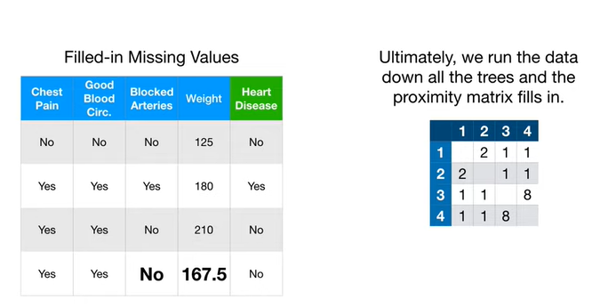

Ultimately we run the data down all the trees and the proximity matrix fills in.

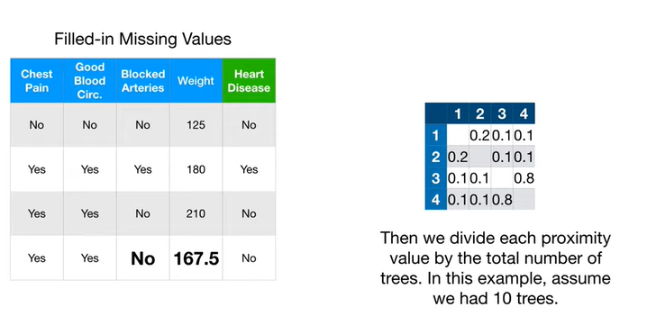

Then we divide each proximity value by the total number of trees in this example assume we have ten trees.

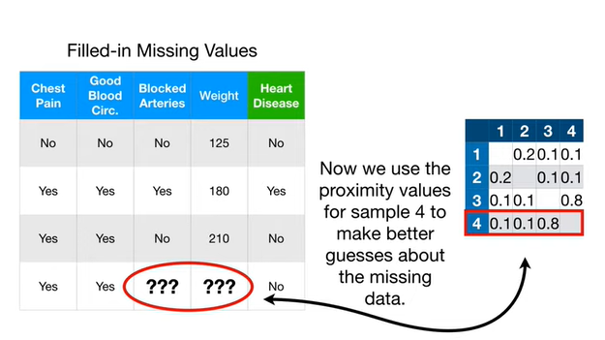

Now we use the proximity values for sample four to make better guesses about the missing data.

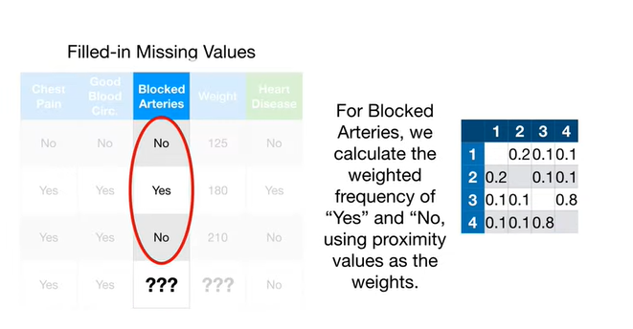

For blocked arterie,s we calculate the weighted frequency of yes and no using proximity values as the weights.

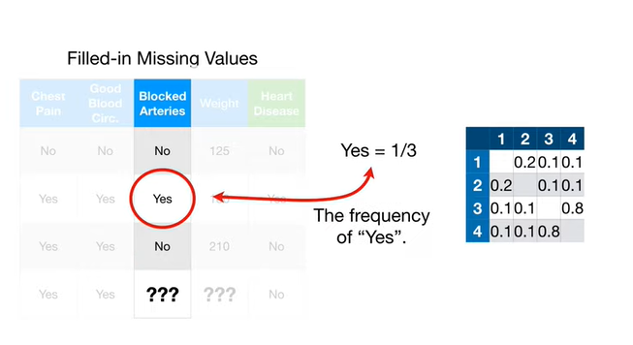

Yes occurs in one third of the samples.

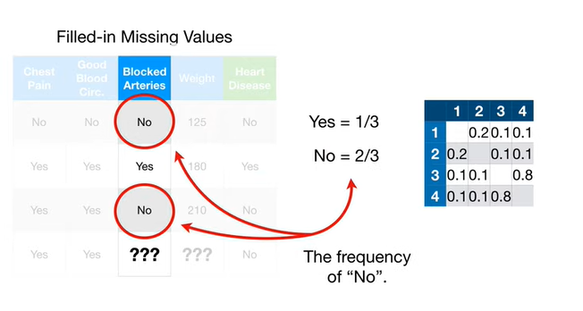

No occurs in two-thirds of the samples.

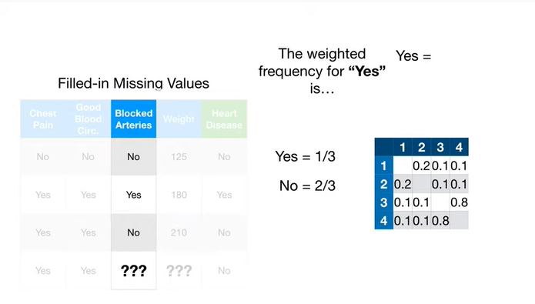

The weighted frequency for yes is

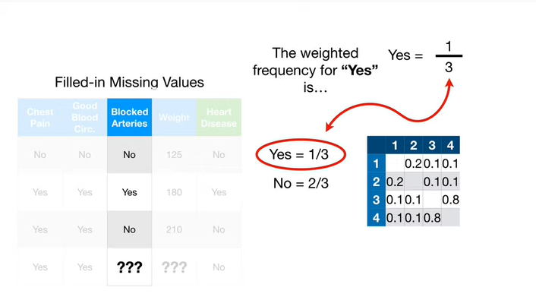

the frequency of yes

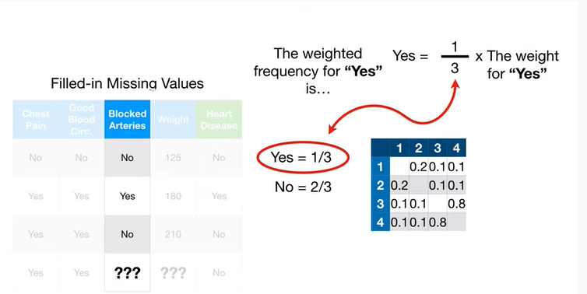

times the weight for yes.

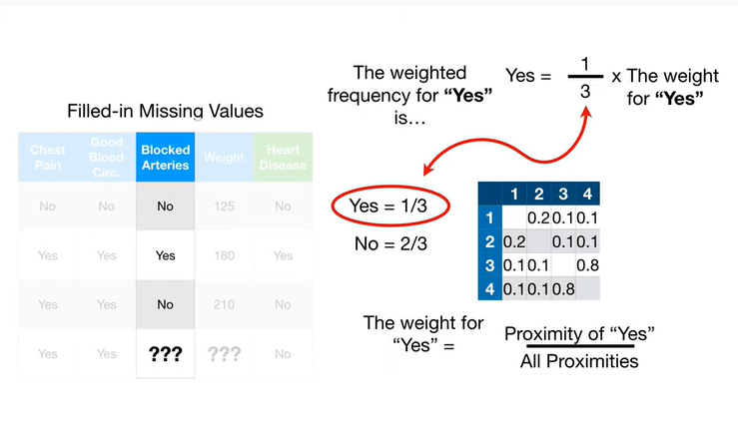

The weight for yes equals the proximity of yes divided by all of the proximities.

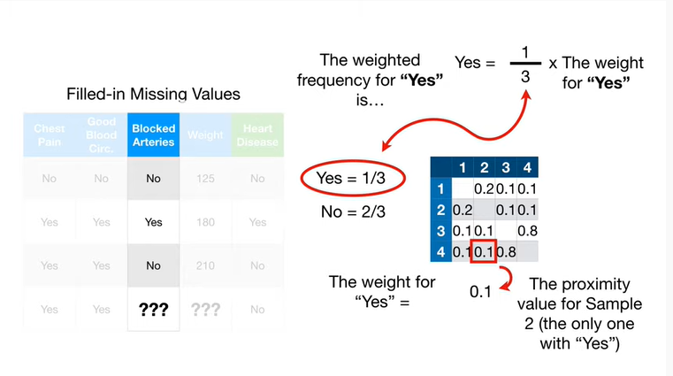

The proximity for yes is the proximity value for sample 2, the only one with yes

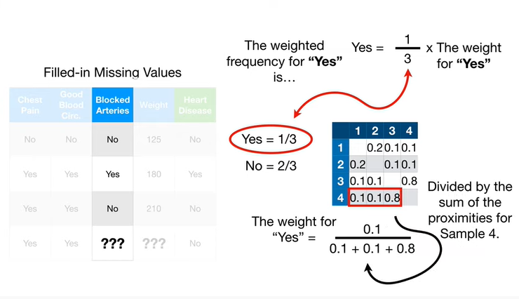

and we divide that by the sum of the proximities for sample 4.

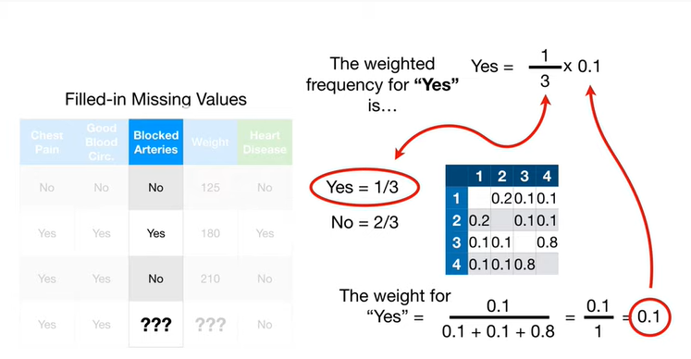

So the weight for yes is 0.1.

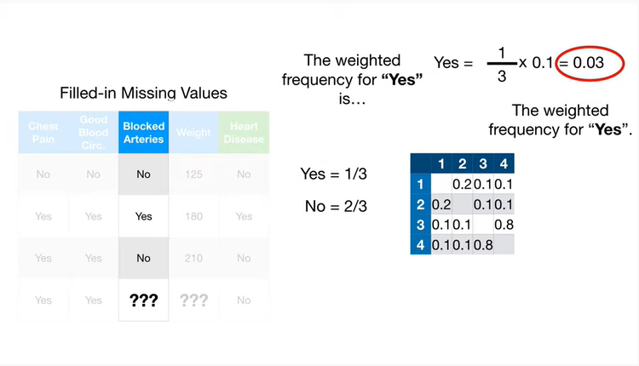

Thus, the weighted frequency for yes is 0.03.

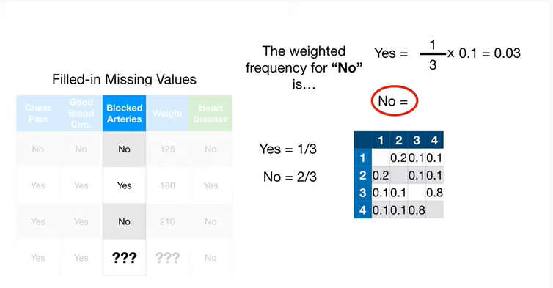

The weighted frequency for no is

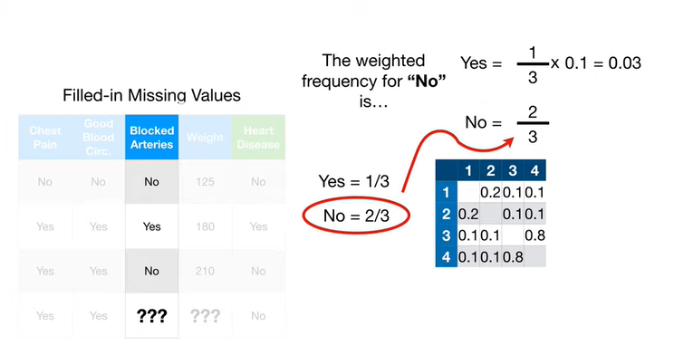

the frequency of no which is 2/3

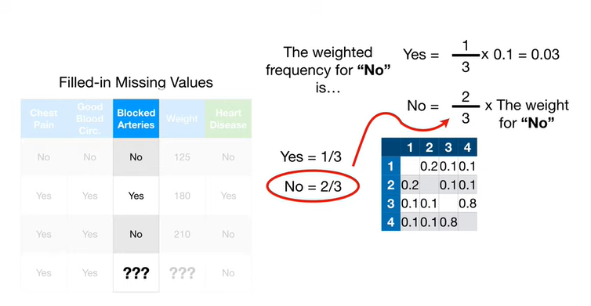

times the weight for no.

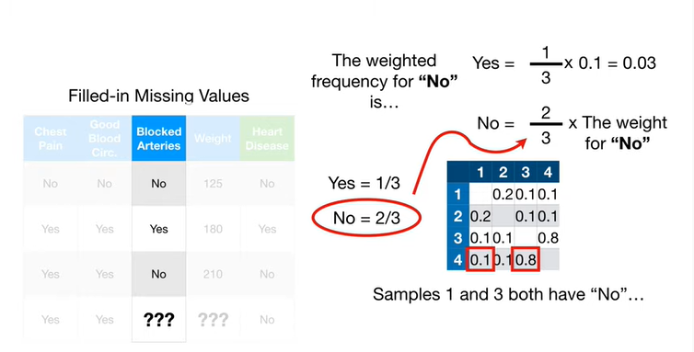

Samples 1 & 3 both have no.

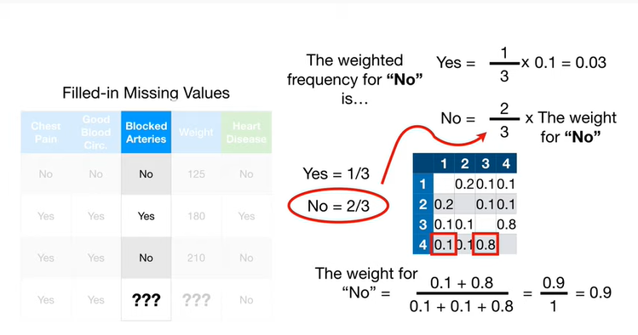

With that in mind, we can plug in the values for the proximity of no / all proximities.

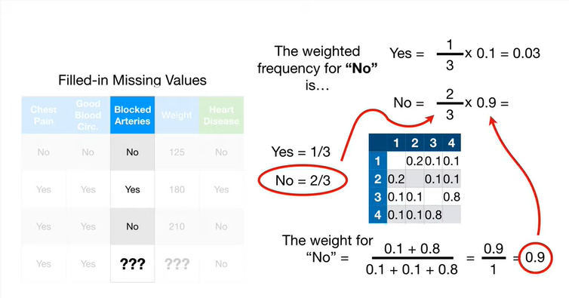

Thus the weight for no is 0.9.

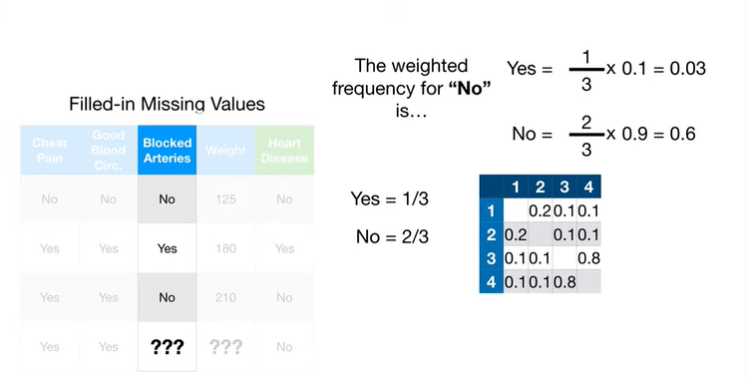

And the weighted frequency for no is 0.6.

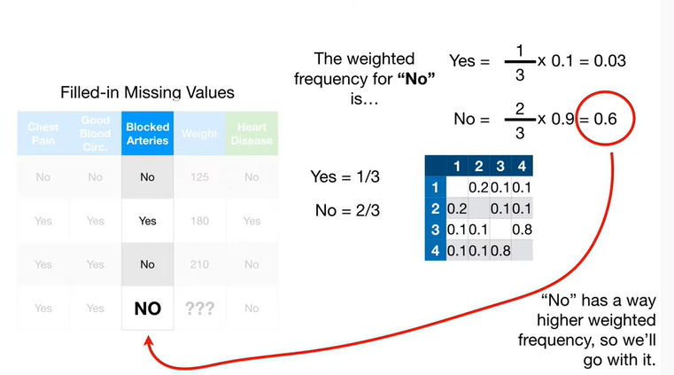

No has a way higher weighted frequency, so we'll go with it.

In other words, our new improved and revised guessed based on the proximities is no for blocked arteries.

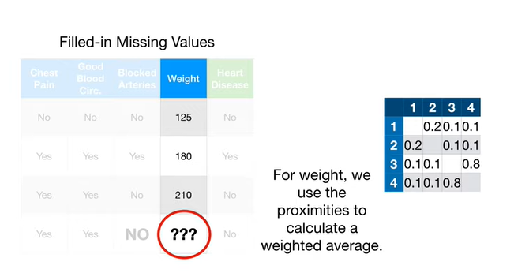

For weight, we use the proximities to calculate a weighted average.

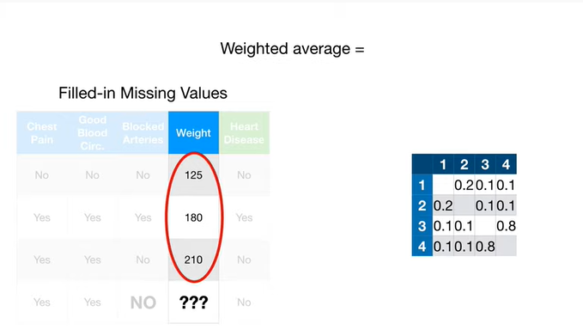

In this case the weighted average equals

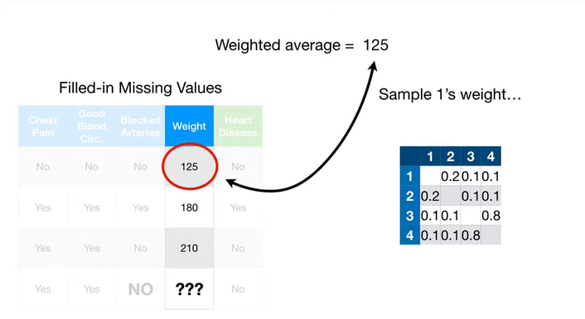

sample ones weight

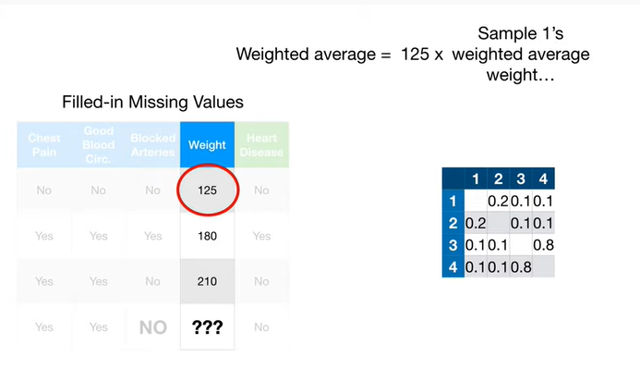

times sample ones weighted average weight… sorry if there's any confusion… between a patient's weight or a samples weight and the weight used in the weighted average.

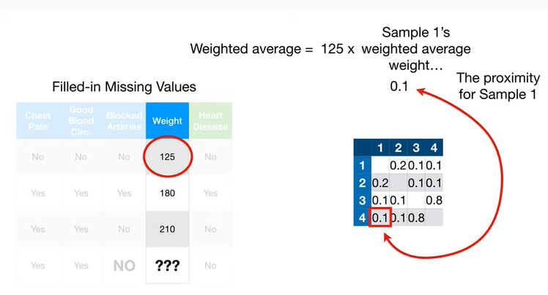

To calculate that weight we start with the proximity for sample 1

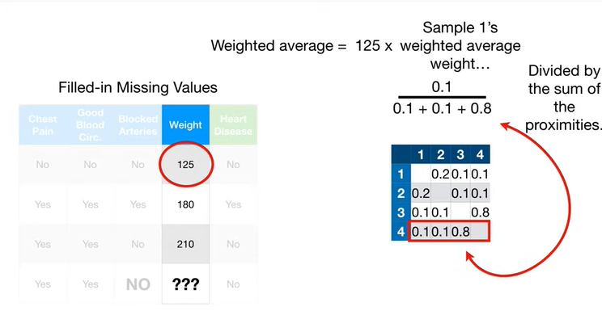

divided by the sum of the proximities.

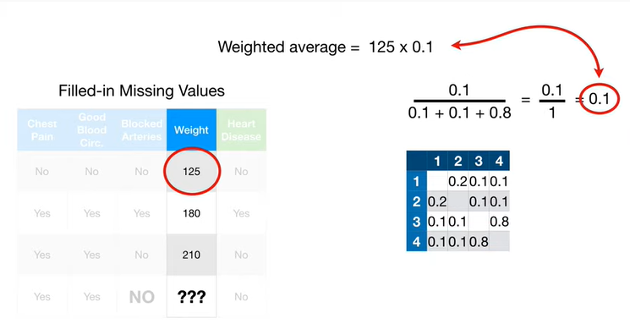

So sample ones weighted average weight is 0.1.

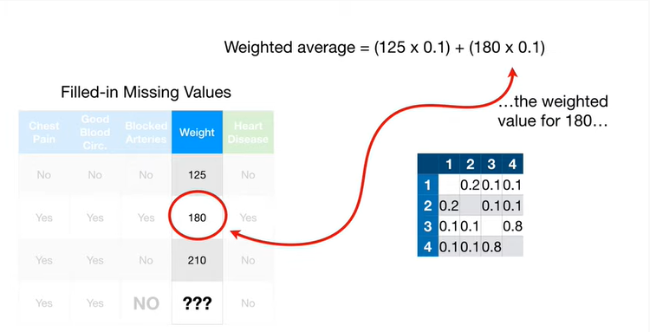

Here's the weighted value for sample number two who weighs 180

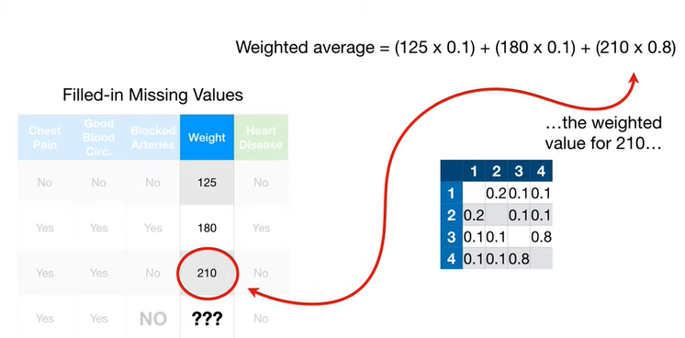

here's the weighted average value for sample number three who weighs 210.

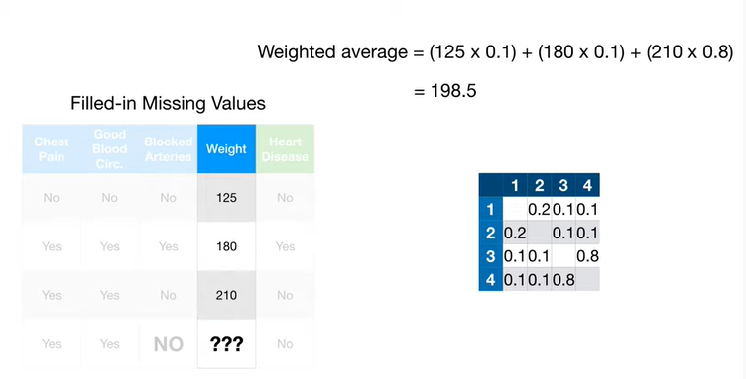

Ultimately the weighted average of weight is 198 point five.

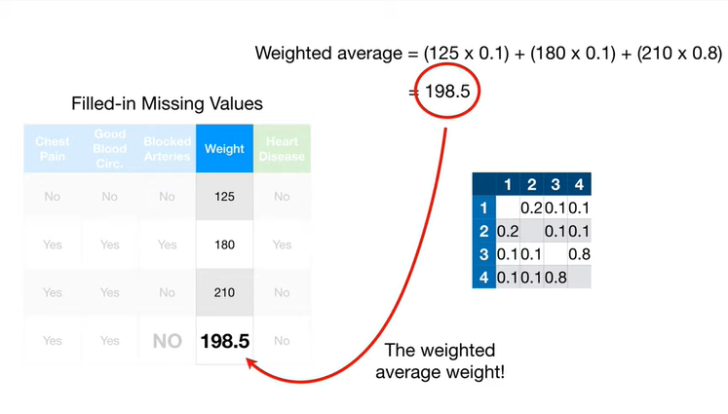

And remember the weights that we used in the weighted average were based on proximites.

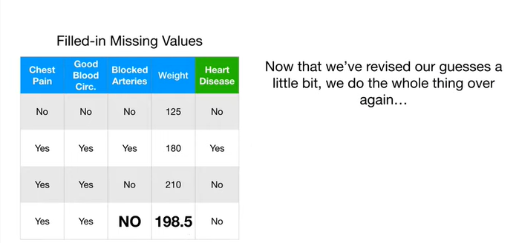

Now that we've revised our guesses a little bit, we do the whole thing over again.

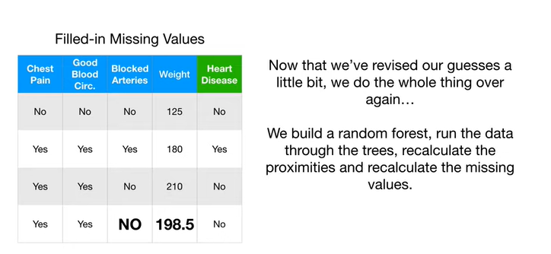

We build a random forest run the data through the trees recalculate the proximities and recalculate the missing values.

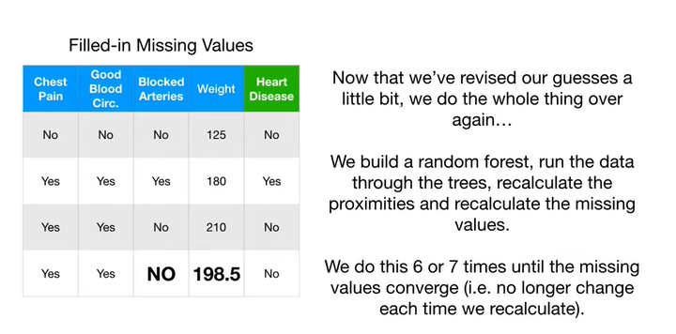

We do this six or seven times until the missing values converge ie no longer change each time we recalculate.

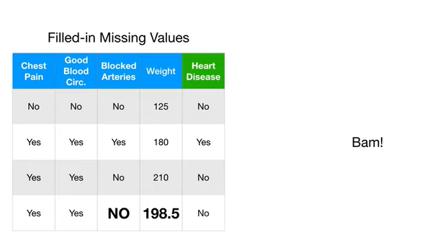

BAM !!!

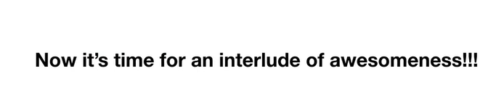

Now it's time for an interlude of Awesomeness.

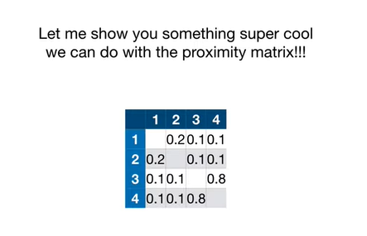

Let me show you something super cool we can do with the proximity matrix.

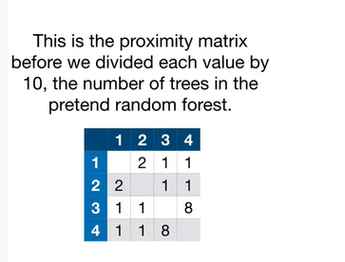

This is the proximity matrix before we divided each value by 10, the number of trees in the pretend random forest.

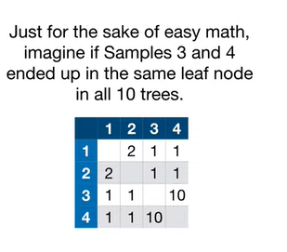

Just for the sake of easy math imagine if samples 3 & 4 ended up in the same leaf node in all 10 trees.

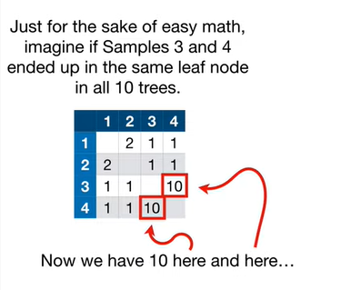

Now we have a 10 here and here.

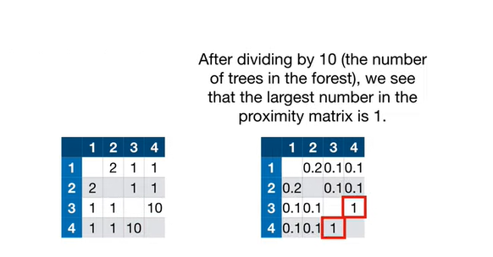

After dividing by 10 (the number of trees in the fores),t we see that the largest number in the proximity matrix is 1.

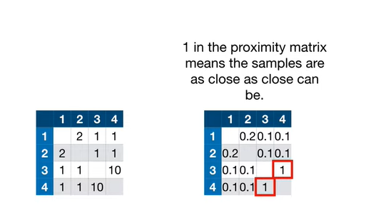

1 in the proximity matrix means the samples are as close as close can be.

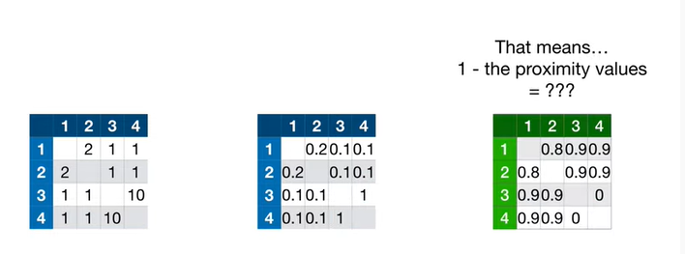

That means 1 minus the proximity values equals ???

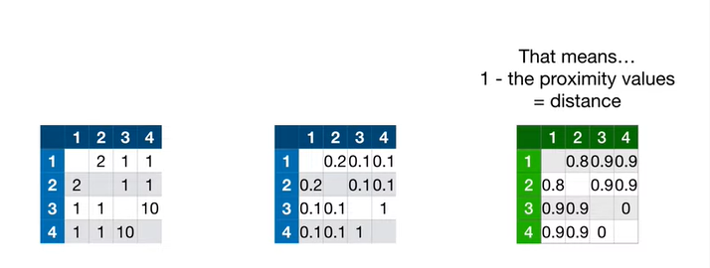

Distance.

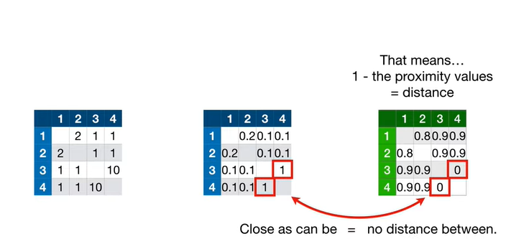

Close can be equals no distance between

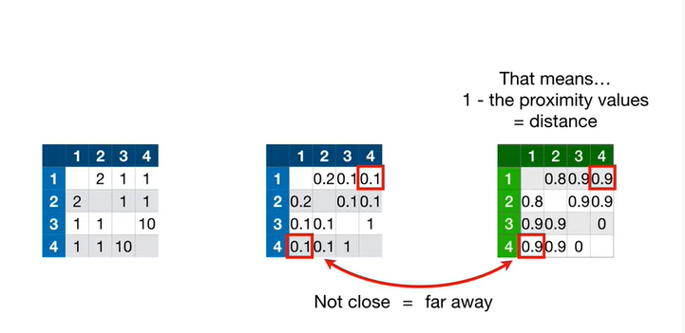

and not close equals far away.

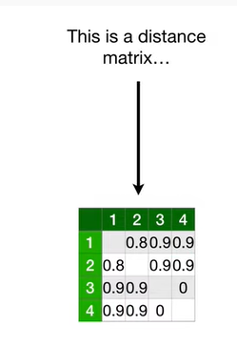

This is a distance matrix

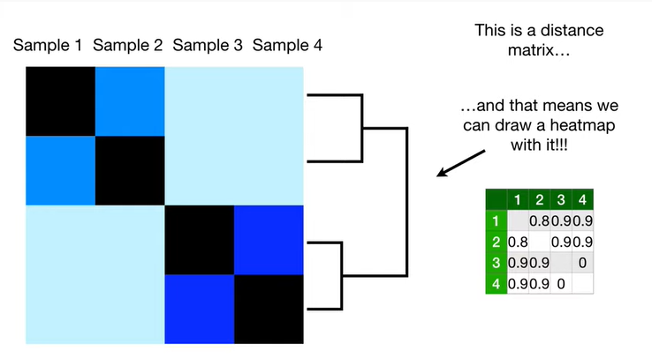

and that means we can draw heat map with it !!!

If you don't know what a heat map is, check out the stat quest.

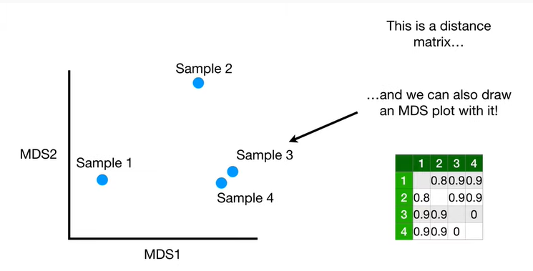

And we can also draw an MVS plot with it.

And if you don't know what an MDS plot is, well check out the stat quest.

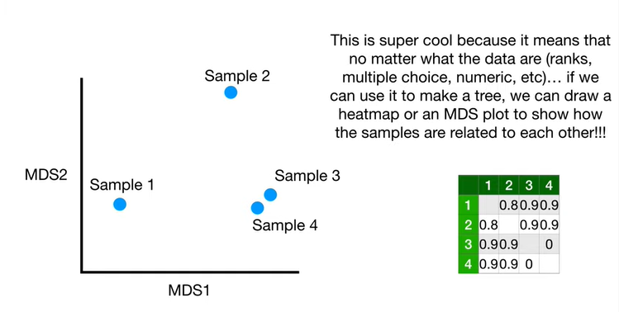

I think this is super cool because it means that no matter what the data are ranks, multiple-choice, numeric etc … if we can use it to make a tree we can draw a heat map or an MDS plot to show how the samples are related to each other !!!

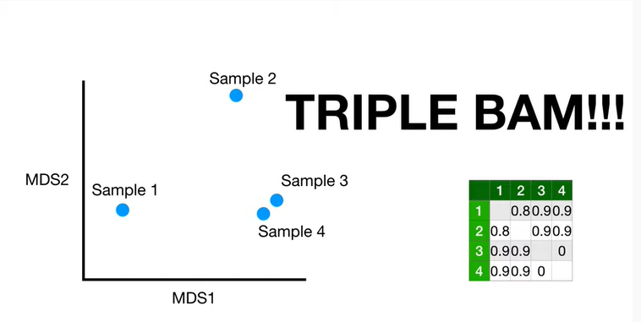

This is awesome.

Triple BAM !!!

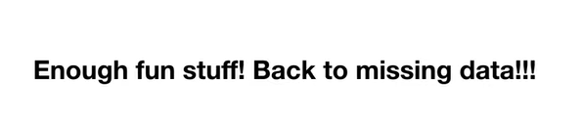

Ok enough fun stuff !

Let's get back to the missing data problem !!!

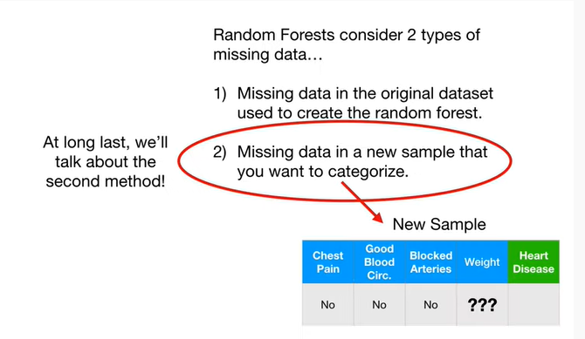

At long last we'll talk about the second method.

This is when we have missing data in a new sample that we want to categorize.

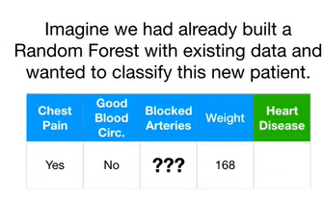

Imagine we had already built a random forest with existing data and wanted to classify this new patient.

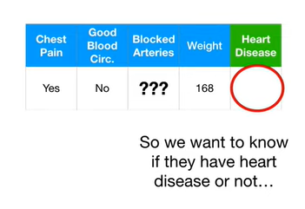

So we want to know if they have heart disease or not

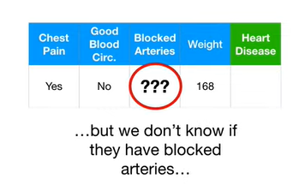

but we don't know if they have blocked arteries

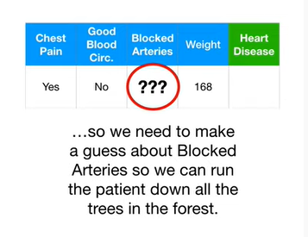

so we need to make a guess about blocked arteries so we can run the patient down all the trees in the forest.

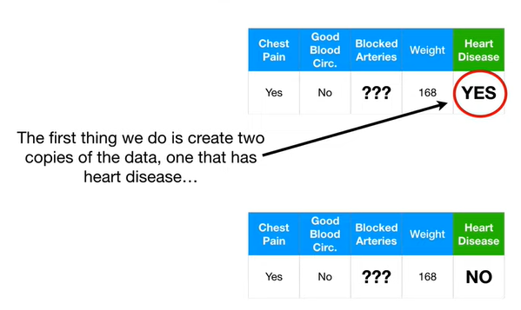

The first thing we do is create two copies of the data, one that has heart disease

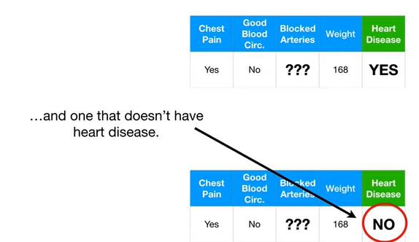

and one that doesn't have heart disease.

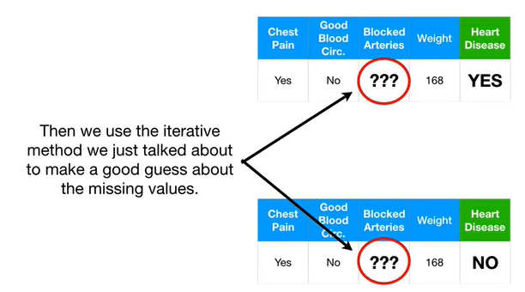

Then we use the iterative method we just talked about to make a good guess about the missing values.

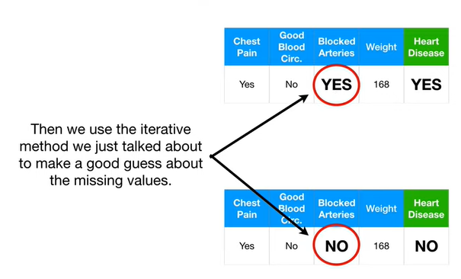

These are the guesses that we came up with.

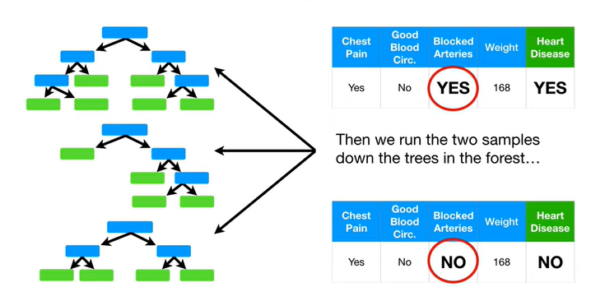

Then we run the two samples down the trees in the forest

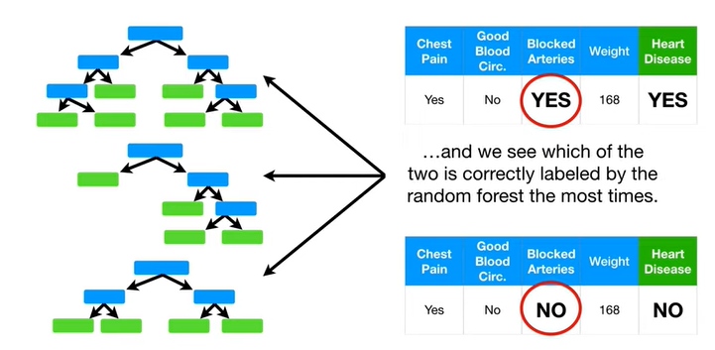

and we see which of the two is correctly labeled by the random forest the most times.

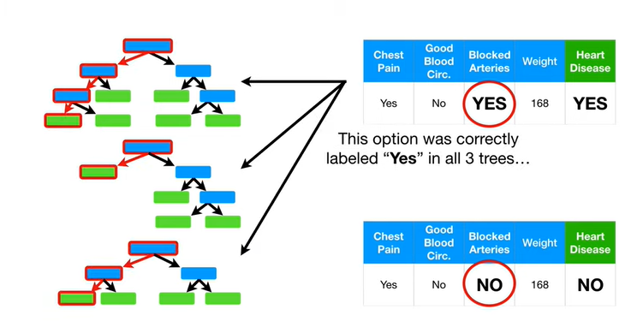

This option was correctly labeled yes in all three trees.

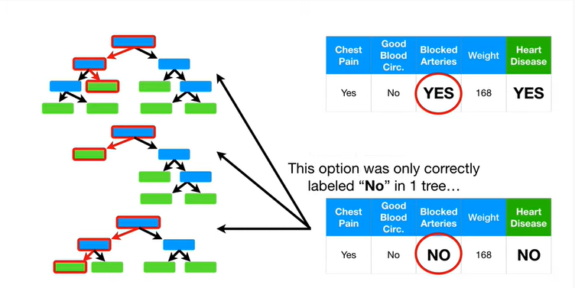

This option was only correctly labeled no in one tree.

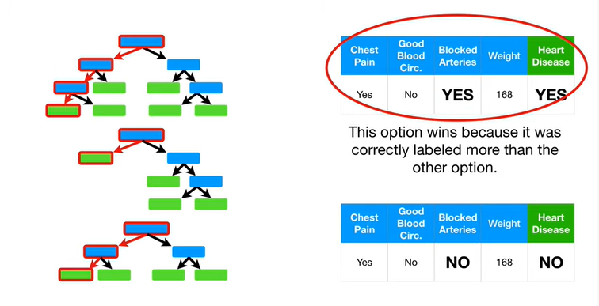

This option wins because it was correctly labeled more than the other option.

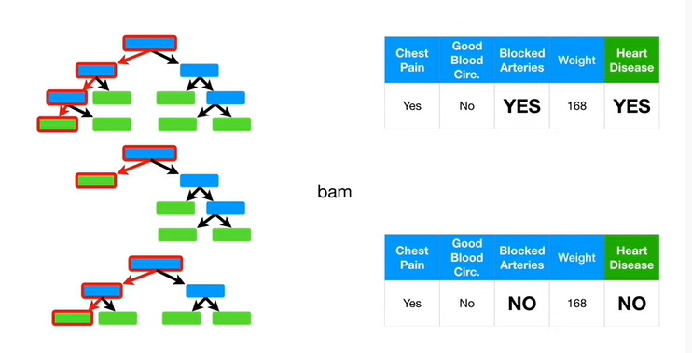

BAM !!!

We filled in the missing data and we've classified our sample.